CS255 Project Two

DriverPass System Design Document

Mohamed Elhassan

mohamed.elhassan@snhu.edu

Southern New Hampshire University

DriverPass System Design Document

Prepared by: Mohamed Elhassan

Date: 4/21/2024

**1. Introduction**

This document outlines the system design for the DriverPass platform, detailing its key components, interactions, and technical requirements. The DriverPass system aims to streamline the process of obtaining a driver's license by providing online resources, scheduling driving lessons, and tracking progress for users.

**2. UML Diagrams**

*2.1 UML Use Case Diagram:*

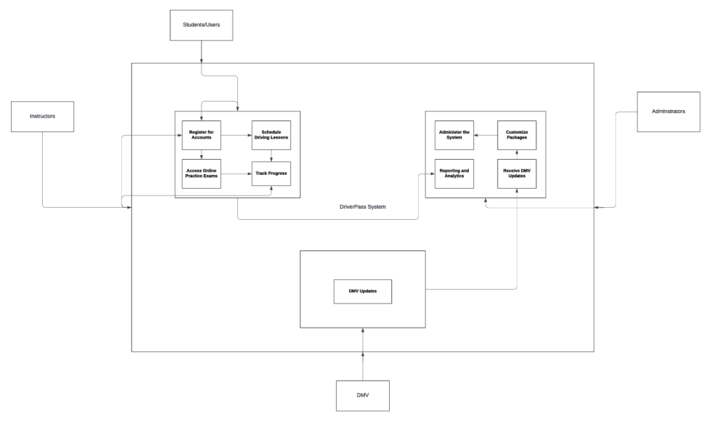

Description:

The UML use case diagram illustrates the various functionalities of the DriverPass system and the interactions between different actors. It helps visualize how users, instructors, administrators, and external systems like the DMV interact with the system to achieve their goals.

*2.2 UML Activity Diagrams:*

2.2.1 Register for Accounts Use Case:

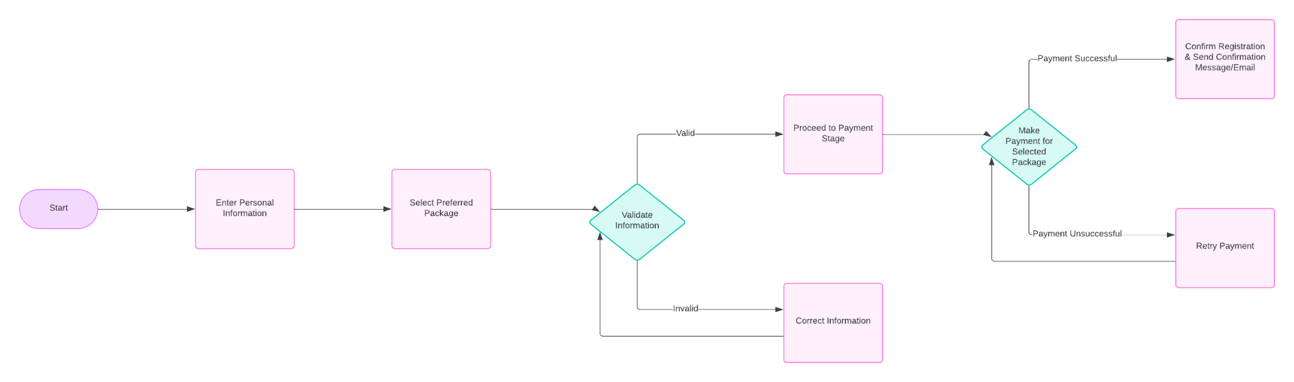Description:

The activity diagram simplifies the registration process for users by outlining the steps involved, from entering personal information to confirming registration. It ensures a smooth and efficient onboarding experience for new users.

2.2.2 Schedule Driving Lessons Use Case:

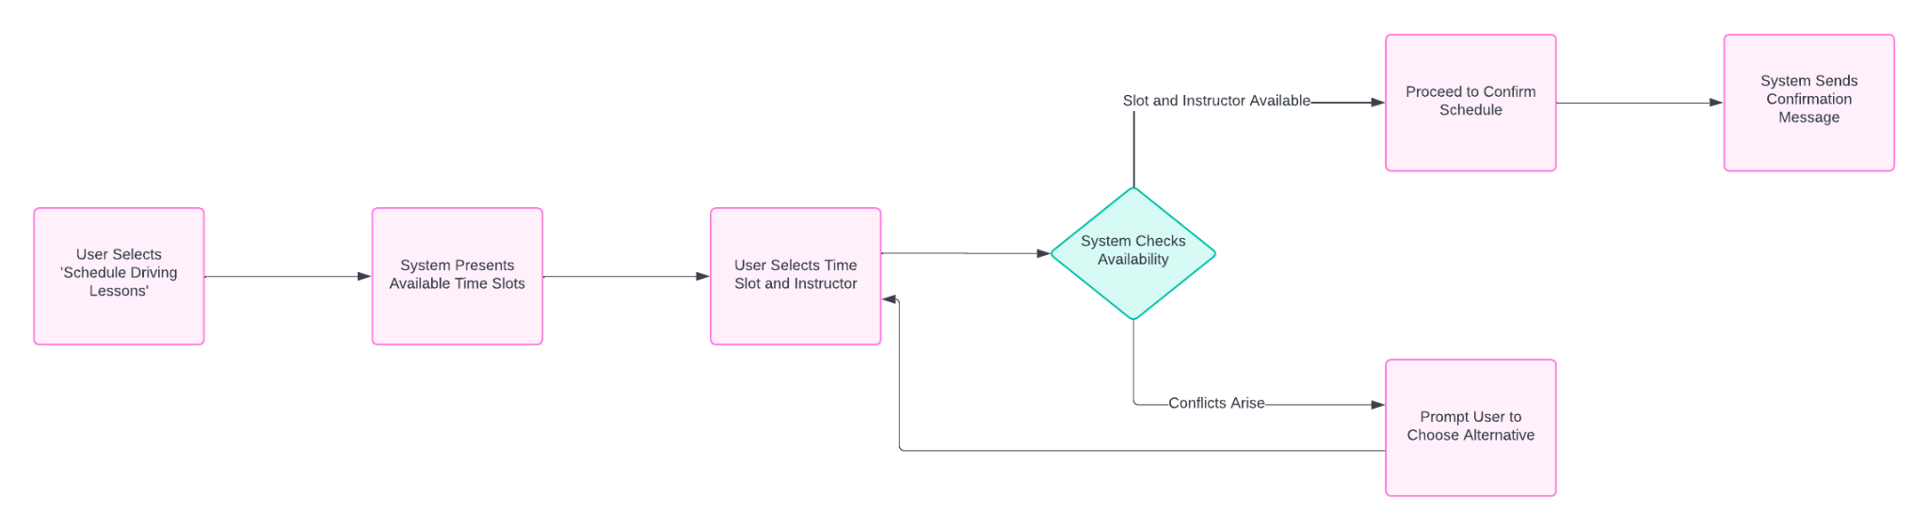

Description:

This activity diagram illustrates the process of scheduling driving lessons, helping users select available time slots, choose instructors, and confirm schedules. It ensures that users can easily book driving lessons according to their preferences.

*2.3 UML Sequence Diagram:*

2.3.1 Sequence Diagram for Scheduling Driving Lessons Use Case:

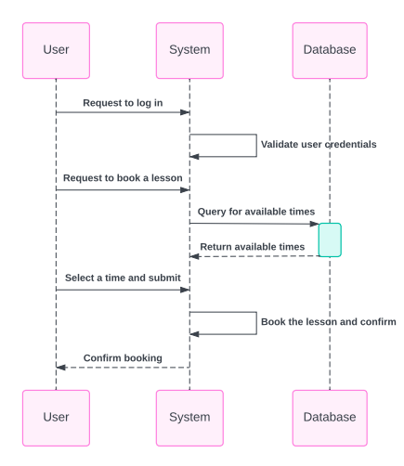

Description:

The sequence diagram depicts the interactions between the user, the system, and instructors during the scheduling of driving lessons. It helps visualize the flow of messages and actions involved in confirming a lesson schedule.

*2.4 UML Class Diagram:*

2.4.1 Class Diagram for DriverPass System: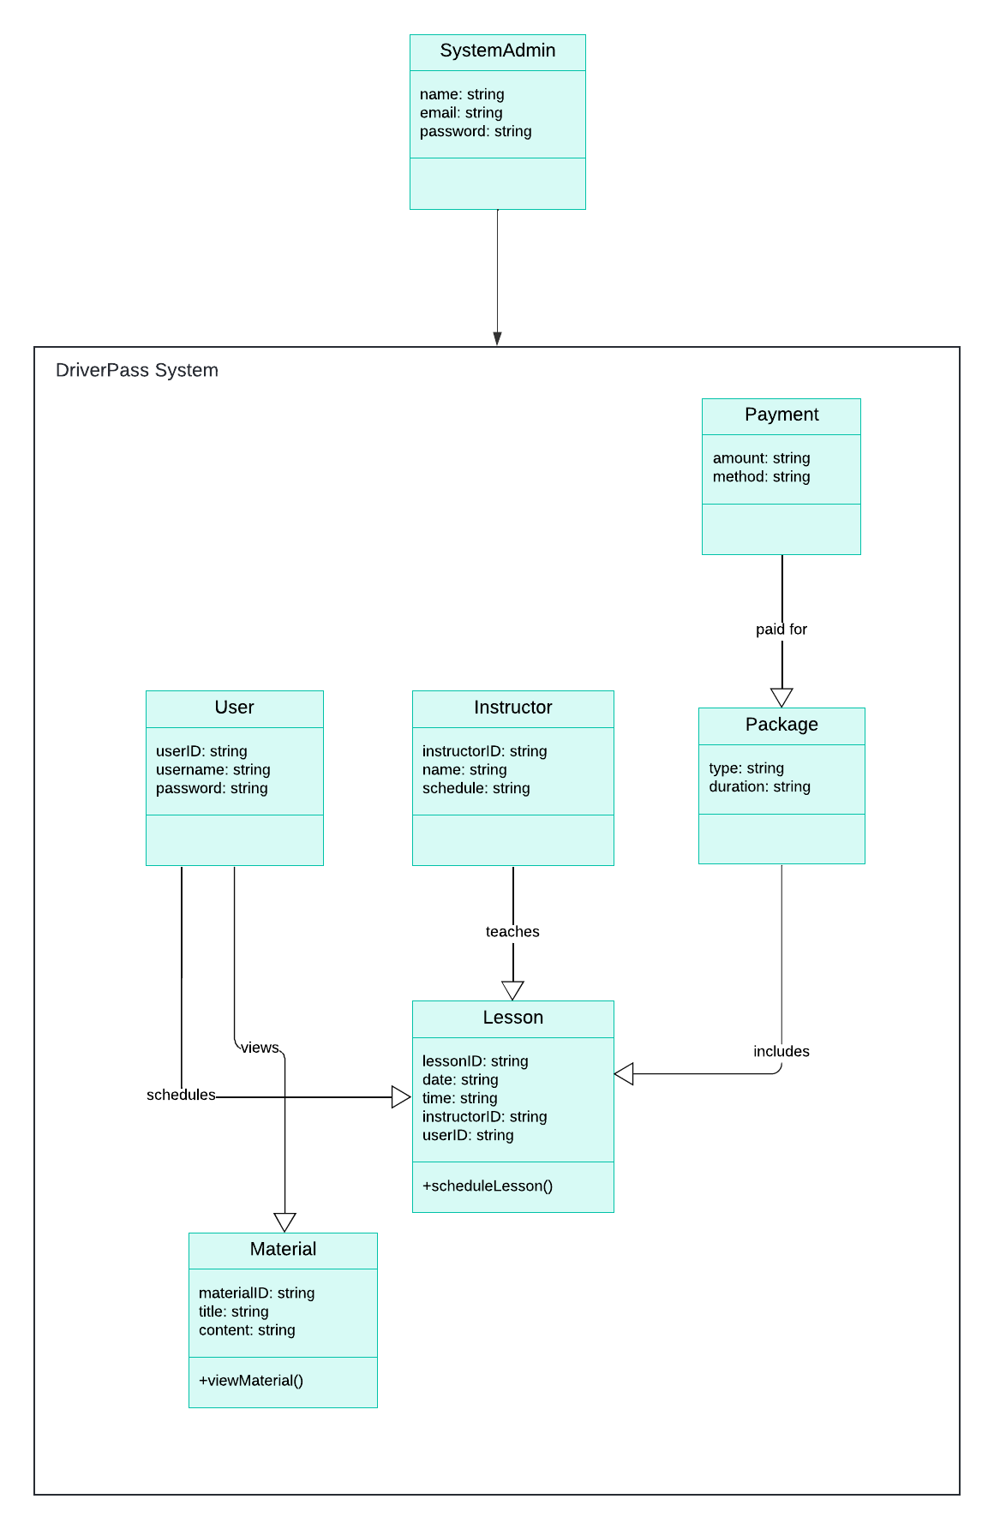

Description:

The class diagram outlines the static structure of the DriverPass system, identifying key classes like User, Instructor, Lesson, Package, Payment, and SystemAdmin. It illustrates the relationships between classes and their attributes, facilitating efficient data management and user interactions.

**3. Technical Requirements**

Based on the functional and non-functional requirements outlined in the business requirements document, the technical requirements for the DriverPass system are as follows:

**Hardware:** Ensure strong server infrastructure capable of handling concurrent user requests and storing large volumes of data securely.

**Software:** Utilize reliable web application frameworks and libraries compatible with modern browsers and mobile devices.

**Tools:** Implement CI/CD pipelines for automating the software delivery process and ensuring efficient deployment.

**Infrastructure:** Leverage cloud services for scalability and redundancy, enabling seamless expansion as the user base grows.

**Security:** Implement RBAC to restrict access to sensitive system functionalities based on user roles.

**Data Protection:** Implement data protection measures to safeguard user information such as encryption of sensitive data, and access controls.

**Scalability:** Design the system architecture to accommodate future growth in user traffic and data volume, utilizing scalable database solutions and caching mechanisms.

**4. Conclusion**

The system design outlined in this document provides a solid foundation for the development of the DriverPass platform. Future enhancements may include integrating additional features such as online driving simulations, expanding support for different types of driver's licenses, and enhancing reporting and analytics capabilities.